Exam 3

A1

b. The essential difference between vinyl and CD audio is that vinyl is analog and CD audio is digital. This means that the vinyl is played back using the physical vibrations of the ridges on the vinyl where the CD is played back using information bits stored on the CD. Each format has its own advantages. Vinyl, due to its physical nature, is smoother sounding. The ridges on vinyl have as much resolution as the atoms on the record allow. A disadvantage that comes with vinyl is, because of how it’s recorded and the medium at which it’s recorded, it cannot produce the same frequencies that a CD can as effectively. Vinyl is subject to outside disturbance, causing the lower frequencies on a record to be less clear as they are the once that are most effected by vibrations in a room. CDs do not have this problem because they use stored information, allowing the sound stored to be played as was intended without effect from physical anomalies. Some disadvantages that come with CD audio are problems with digital artifacts and resolution. Artifacts occur in multiple instances, which can be caused by low quality equipment when recording, burning, and playing back, as well as phenomenon such as aliasing. Vinyl does not have as much of these problems because it is in its nature to reduce information as little as possible. The resolutions on CDs also create a barrier for the highest possible recorded frequency because of a computer’s need to deal with a finite set of data. This causes digital audio to have a highest possible cut-off frequency depending on how much data is being recorded per second. In CD’s, this frequency, referred to as the Nyquist Frequency, is usually 22050 Hz. In the end, vinyl and CD each have their advantages and disadvantages.

A2

A student is recording his 2 minute long audition piece for the Eastman School of Music and wants to deliver the best recording possible. Unfortunately, he can only send in a maximum of 25 MB of information for his application because Gmail is cheap. A player with a good tone is considered only create harmonics up to 10K Hz. In order to have the best recording, what is the maximum recording resolution the trumpet player should set his recording to?

287

There are 209715200 bits in 25 MB. The relevant highest frequency is 10k Hz, so anything above that is unneeded (and supposedly will not be played). The sampling rate should then be set to 20K Hz. The piece is 2 minutes long. Therefore, there will be 24000 samples. This allows for there to be 209715200/ (24000x120) bits per sample, or about 87 bits per sample maximum. The highest resolution per sample will then be determined an exponential factor of 2. In this case, it is 287 bit resolution because each sample will use 87 bits of in formation. If the recording were shorter, the resolution could be higher. If it were longer, the bit resolution would need to be lower.

A3

What is the maximum quantization a sample of 50 db intensity go through if it were being recorded at 16 bits of resolution?

1. 1 db
2. 1024 bytes
3. 1.6 x 10-3 db
4. 96/16 db

C

About how much information does 5 minutes of commercial CD quality audio hold?

1. 25 MB
2. 2.5 MB
3. 216 bits
4. 1.6 x 10-3 db

A

B1

b. The Fourier transform is a system of analyzing a set of data used to understand the harmonic consistency of that set of data. In this case, the set of data used is harmonic in nature. Timbre is a way to describe the tone of a sound. The tone of a sound, or what makes sounds sound different at equal frequencies, is determined by its harmonic components. Adding different amplitudes of sine and cosine waves of frequencies that are multiples of a base, or fundamental, frequency is the basis of all sound. This means that any sound has a unique harmonic composition. Fourier transform allows someone to analyze a set of musical data in time and figure out what that harmonic composition is or would be indefinitely. Once the harmonic composition is complied, then it is possible to use that data to describe a certain samples timbre and also possible use that information in applications such as additive synthesis to recreate those sounds.

B2

Every morning, you hear a bird tweeting outside your window and want to capture its sound and use it as a tuned instrument across many different notes. Bird whistles are relatively pure, so their harmonic composition only has 5 relevant harmonics that affect its tone and it tweets at a frequency of about 800 Hz. If the recording is going to be 2 seconds long, at what is the minimum sample rate at which the tweeting must be recorded?

At least 8K Hz

The tweet must be recorded to include relevant harmonics, the highest being 4K Hz. The frequency resolution of the transform will be 1/T, or in this case .5 Hz. Therefore, there will be a need of at least 8001 nodes of information needed to encompass all the frequencies up to 4K Hz tweeted by the bird. Therefor there needs to be a sampling rate of at least 8K Hz in order to represent the frequencies up to 4000 Hz.

B3

A sound has been sampled at 32 Hz and has produced 128 samples of information. What is the frequency density going to be of an applied Fourier transform?

1. 4
2. .25
3. .5
4. 2

B

A sine wave of 200 Hz is being recorded at a sampling rate of 44100 for 2 seconds. How many non-zero values will be produced if a Fourier transform is applied to the sample?

1. .5
2. 200 Hz
3. 22050
4. 1

D

C1

c. The Schroeder reverb effect is meant to reproduce what a room’s reverb would sound like. Because a room is usually enclosed, a sound created within the room will bounce back and forth between the surfaces of the walls. This creates what humans call reverberation, often times used as a tool to help our brain get a feel for the size of a room without having to actually measure it. The Schroeder reverb effect takes into account the fact that multiple parallel walls will create different instances of reverb within a room. In a room with 6 walls and 3 sets of parallel sides, a rectangular prism, the distances between each pair of walls create a reverb effect. The sound will bounce back and forth from each wall, losing energy 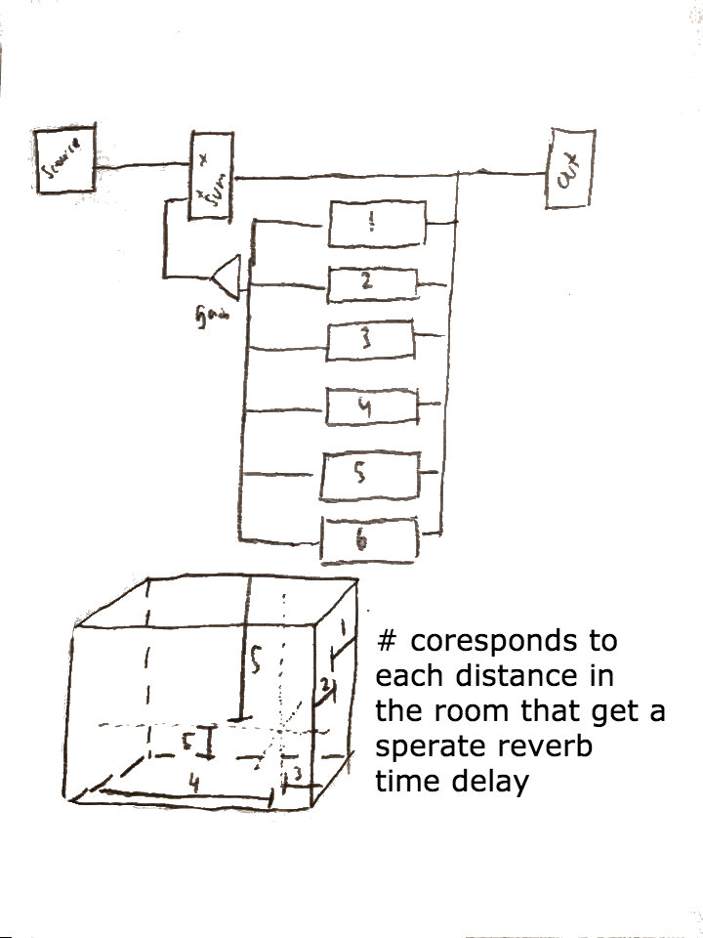for every time that it bounces. The time it takes for the sound to bounce off a wall and come back to its source is the delay time and a gain of less then one can represent the percentage of energy lost with every bounce. It is important to note that a sound will pass by its origin twice while bouncing off each wall once. If the sound source is not centered in the room, there will 6 different delay units controlling the reverb, each considering the time it takes for the sound to bounce from one wall back to it’s source.

C2

A video game music designer wants to emulate the reverb effect of different rooms within a game. Every time a character speaks, he wants the voice to be applied to the appropriate reverb depending on what room he is in. In this case, he is designing the reverb for a cave whose dimensions are 100x20x10 meter. The sound will always come back 70% as loud every time it hits of a wall. If the character is standing in the middle of the room, what should the delay time be for each wall? Assume the cave happens to be a box.

.29 seconds for the 100 m length.

.059 seconds for the 20 m width.

.029 seconds for the 10 m height.

Each of the resulting signals should have a .7 gain for every bounce made.

C3

Someone wants to create a Comb filter whose valleys are at every 100th starting at 50 Hz. What should the delay constant τ be?

1. .001
2. .005
3. .01
4. .05

C

Someone want to create a Comb filter whose frequency response only dips a maximum of 20% below the source frequency at each valley. What should the gain a1 be?

1. .02
2. .2
3. 2
4. 20

B